**Lab 4**

**Name :-** Aryan Dilipbhai Langhanoja

**Date :-** 24-07-2023

**Enrollment No :-** 92200133030

**CO1: To write, test, and debug simple Python programs**

**CO2: To implement Python programs with conditional, loops and functions**

**Task 1:- Formating Strings**

**Python Code:**

A = "{} Marwadi University , {}"

print(A.format('ICT ','Rajkot'))

B = "{1} Marwadi University , {0}"

print(B.format('ICT ','Rajkot'))

C = "{UniversityName} University , {CityName}"

print(C.format(UniversityName = "Marwadi",CityName = "Rajkot"))

per = (12345678/500) * 100

D = "Result = {r:0.2f} %".format(per)

print(D)

**Output:**

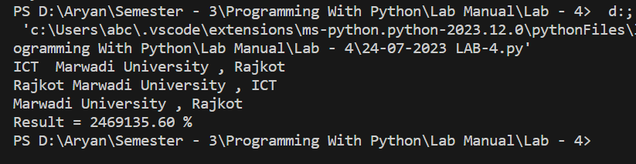

**Task 2:- Demonstrating The Use Of Tuples**

**Python Code:**

tuple1 = ("A",1,1+2j,1.25)

tuple2 = ("B",1.25,6,"C")

print(tuple1)

print(tuple1[0])

print(tuple1[1])

print(tuple1[2])

print(tuple1[3])

print(tuple1[0:4])

print(len(tuple1))

print(tuple1 + tuple2)

print(len(tuple1 + tuple2))

tuple3 = ('ABC',2.53,1+3j,2+4j,6)

tuple4 = ('A','B','C',7+2j)

tuple5 = tuple3[2:4] + tuple4[3:4]

**Output:**

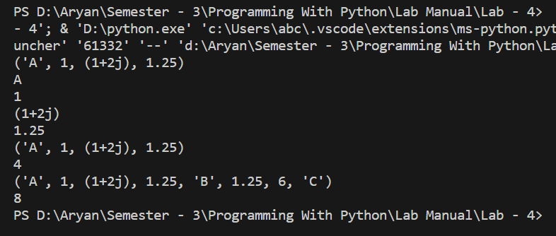

**Task 3:- Demonstrating The Use Of List**

**Python Code:**

list1 = ['A' , 2.5 , 2+3j , 6]

list2 = [3.7 , 'B' , True , 6+4j]

print(list1[0])

list1[0] = 5

print(list1 + list2)

print(type(list(tuple1)))

**Output:**

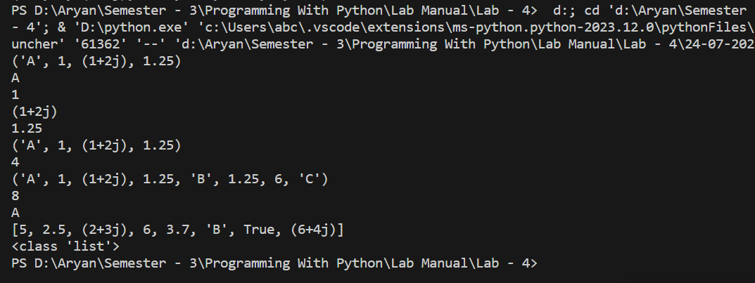

**Task 4:- ImplementingThe List Functions**

**Python Code:**

list9 = ["Aryan"]

list9.append("Langhanoja")

print(list9)

list9.insert(1,"Dilipbhai")

print(list9)

list10 = ["Is Great"]

list9.extend(list10)

print(list9)

**Output:**

